**America’s Biggest Economic Challenge May Be Demographic Decline**

**Slower growth in the working-age population is a problem in much of the country. Could targeted immigration policy help solve it?**

*The New York Times – Upshot* - By [Neil Irwin](https://www.nytimes.com/by/neil-irwin) - April 3, 2019

For many years, American economists have spoken of Japan and Western Europe as places where the slow grind of demographic change — masses of workers reaching retirement age, and smaller generations replacing them — has been a major drag on the economy.

But it is increasingly outdated to think of that as a problem for other countries. The deepest challenge for the United States economy may really be about demographics. And our understanding of the implications is only starting to catch up.

A [new report](https://eig.org/wp-content/uploads/2019/04/Heartland-Visas-Report.pdf) from the Economic Innovation Group, a Washington think tank funded in large part by tech investors and entrepreneurs, adds rich new detail, showing that parts of the United States are already grappling with Japanese-caliber demographic decline — 41 percent of American counties with a combined population of 38 million.

At the national level, slower growth in America’s working-age population is a major reason that mainstream forecasters now expect the economy to expand around 2 percent each year rather than the 3 percent common in the second half of the 20th century. As a matter of simple arithmetic, lower growth in the number of people working will almost certainly mean slower growth in economic output.

But demographic change doesn’t hit everywhere equally. Besides the inevitable effect of the extra-large baby boom generation hitting retirement age and stepping away from the work force, decisions by working-age people can accentuate or lessen the impact of that underlying shift.

Many younger workers move to bustling urban centers on the coasts, leaving smaller cities and rural areas behind. Immigrants bolster the labor force but also disproportionately go to those same big coastal cities.

“Dayton’s height of population was 1953, and we’ve seen stagnant growth for the region since 1990,” said Nan Whaley, the mayor of the Ohio city.

“A lot of people say this was just going to happen, that this is the way it is — I hate that comment,” she said, arguing that policy decisions hadincentivized investment in coastal cities.

Over all, 80 percent of American counties encompassing 149 million people experienced a decline in the number of residents ages 25 to 54 between 2007 and 2017, according to the paper, which was written by Adam Ozimek of Moody’s Analytics and Kenan Fikri and John Lettieri of the Economic Innovation Group.

They project that the trends will continue, and that by 2037, two-thirds of American counties will have fewer adults of prime working age than they did in 1997, despite overall population growth in that period. (Their projections tried to take into account undocumented immigrants.)

Policies to encourage American families to have more children would help over the long run by increasing the supply of potential workers in the future. So could efforts to ensure that even struggling cities have the kinds of amenities young families desire, particularly good schools.

The population of different places is always fluctuating, and economists have traditionally viewed that as a mostly healthy process. Workers make their way to where they will be the most productive, enabling the overall economy to adapt and grow.

But people who study regional economies are increasingly concerned that some aspects of this wave of demographic change make the pain more severe for places left behind — which can get stuck in a vicious cycle.

“There’s a possibility that once local areas start on this downward spiral, it’s self-reproducing,” said Timothy Bartik, a senior economist at the W.E. Upjohn Institute for Employment Research.

A shrinking supply of working-age people can prompt employers to look elsewhere to expand, making it harder for local governments to raise enough taxes to pay for infrastructure and education, and encouraging those younger people who remain to head elsewhere for more opportunity.

It raises the possibility that, if unchecked, these demographic trends might not merely reduce overall national growth rates in the decades ahead. They could also cause the left-behind cities to hit a point of no return that undermines the long-term economic potential of huge swaths of the United States.

The authors of the E.I.G. report suggest a potential solution: an immigration policy that would stop the vicious cycle. They propose that visas could be made available to skilled immigrants on the condition they go to one of the areas struggling with demographic decline. The idea would be to create growth in the working-age population in those places, increasing the tax base and the demand for housing, and giving businesses reason to invest.

“The real power of this is that it would start to change how investors, businesses and entrepreneurs view locational decisions,” said Mr. Lettieri, the president of the group. “They would know that there is this new pipeline for talent.”

Given hostility to immigration in large segments of the country, he said, places should be able to elect whether to make visas available to immigrants as part of an economic development strategy. It would have to be a “dual opt-in” approach in which both the community decides it wants more immigration, and individual immigrants elect to move there.

Dayton is the kind of place where that approach may just [have some appeal](https://www.daytondailynews.com/news/local/dayton-immigrant-population-doubles-you-can-get-better-life/ecabN8dahr9PwpdmwgX7QI/). Ms. Whaley, the mayor, said a program called “[Welcome Dayton](https://www.nytimes.com/2013/10/07/us/ailing-cities-extend-hand-to-immigrants.html?module=inline),” intended to help immigrants move to the city, has been helpful in holding the population steady after a long pattern of losses.

Programs like that, she said, combined with a low cost of living and investment in community colleges to create qualified workers, can give smaller cities like Dayton the means to break out of demographic ruts.

Regardless of what one thinks about using immigration policy to try to arrest demographic decline, there’s a more basic point that everyone who cares about the United States’ economic future must wrestle with.

Demography may be the most powerful economic force of them all, and for much of the United States, the trend lines, for now, are pointing in the wrong direction.

Trump Says the U.S. Is ‘Full.’ Much of the Nation Has the Opposite Problem.

An aging population and a declining birthrate among the native-born population mean a shrinking work force in many areas.

*The New York Times – Upshot* - By [Neil Irwin](https://www.nytimes.com/by/neil-irwin) and [Emily Badger](https://www.nytimes.com/by/emily-badger) - April 9, 2019

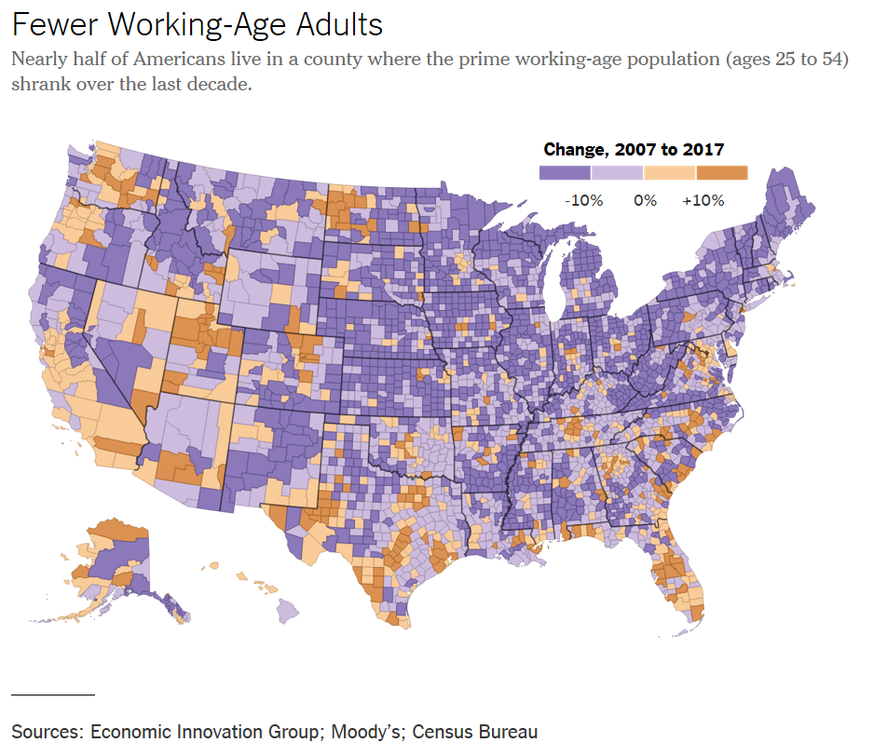

President Trump has adopted a blunt new [message](https://www.nytimes.com/2019/04/06/us/politics/trump-jews-border-asylum.html?module=inline) in recent days for migrants seeking refuge in the United States: “[Our country is full](https://twitter.com/realDonaldTrump/status/1115057524770844672).”

To the degree the president is addressing something broader than the recent strains on the asylum-seeking process, the line suggests the nation can’t accommodate higher immigration levels because it is already bursting at the seams. But it runs counter to the consensus among demographers and economists.

They see ample evidence of a country that is not remotely “full” — but one where an aging population and declining birthrates among the native-born population are creating underpopulated cities and towns, vacant housing and troubled public finances.

Local officials in many of those places view a shrinking population and work force as an existential problem with few obvious solutions.

“I believe our biggest threat is our declining labor force,” said Gov. Phil Scott of Vermont, a Republican, in his [annual budget address](https://governor.vermont.gov/press-release/governor-scott-delivers-annual-budget-address) this year. “It’s the root of every problem we face.

“This makes it incredibly difficult for businesses to recruit new employees and expand, harder for communities to grow and leaves fewer of us to cover the cost of state government.”

Or if you look at a city like Detroit, “many of the city’s problems would become less difficult if its population would start growing,” said Edward Glaeser, a Harvard economist. “All sorts of things like the hangover pension liability become much more solvable if you’re actually looking at new people coming in.”

This consensus is visible in official government projections. The Congressional Budget Office foresees the American labor force rising by only 0.5 percent a year over the coming decade, about one-third as fast as from 1950 to 2007. That [is a crucial reason](https://www.nytimes.com/2019/04/03/upshot/americas-biggest-economic-challenge-may-be-demographic-decline.html?module=inline) that economic growth is forecast to remain well below its late 20th-century levels.

And that, in turn, is reflected in the national fiscal outlook. There are now 2.8 workers for every recipient of Social Security benefits, a rate on track to fall to 2.2 by 2035, according to the program’s trustees. Many state pension plans face even greater demography-induced strains.

In smaller cities and rural areas, demographic decline is a fundamental fact of life. A [recent study](https://eig.org/wp-content/uploads/2019/04/Heartland-Visas-Report.pdf) by the Economic Innovation Group found that 80 percent of American counties, with a combined population of 149 million, saw a decline in their number of prime working-age adults from 2007 to 2017.

Population growth in the United States has now hit its lowest level [since 1937](https://www.nytimes.com/2018/12/19/us/census-population-growth.html?module=inline), partly because of a [record-low](https://www.nytimes.com/2018/05/17/us/fertility-rate-decline-united-states.html?module=inline) fertility rate — the number of children born per woman. The United States increasingly has population growth rates similar to slow-growing Japan and Western Europe, with immigration partly offsetting that shift.

The Trump administration has portrayed the surge of asylum seekers at the southern border as a crisis, and applied aggressive tactics to deport undocumented immigrants already in the United States. But it has also announced [plans](https://www.nytimes.com/2019/04/08/us/politics/trump-administration-h2b-visa.html?module=inline) to issue up to 30,000 additional H-2B visas for temporary workers.

“That immigrants keep showing up here is a testament to our freedom and the economic opportunity here,” said Matthew Kahn, an economist at the University of Southern California. If immigrants weren’t trying to come — if *they* believed the United States to be full — that would be a problem, Mr. Kahn said.

A particular fear, said John Lettieri, president of the Economic Innovation Group, is that declining population, falling home prices and weak public finances will create a vicious cycle that the places losing population could find hard to escape.

He proposes a program of “heartland visas,” in which skilled immigrants could obtain work visas to the United States on the condition they live in one of the counties facing demographic decline — with troubled counties themselves deciding whether to participate.

Although some of the areas with declining demographics are hostile to immigration, others, cities as varied as Baltimore, Indianapolis and Fargo, N.D., have embraced the strategy of encouraging it.

“One of the key solutions is to welcome immigrants into these communities,” said Brooks Rainwater, director of the National League of Cities’ Center for City Solutions.

Many parts of the country that are growing in population and that are more economically dynamic have depended on the arrival of immigrants for that success.

Sun Belt metros like Dallas and Phoenix have been built on the logic of rapid expansion — of quickly built homes, of poached employers, of new highways paved to ever-newer subdivisions. Their economic development strategy *is* growth. Their chief input is people — the more, the better.

“Growth cities need immigrants to continue their growth,” said Joel Kotkin, executive director of the Houston-based Center for Opportunity Urbanism, which promotes policies to help cities grow. “The older historically declining cities need immigrants to reinvigorate their economies. And the expensive cities need them because, frankly, white people, African-Americans and middle-class people are leaving for more affordable areas.”

As many industrial cities have lost population since the mid-20th century, Americans have built whole new metropolises on land that was virtually empty then. The Las Vegas metropolitan area, with more than two million people today, had [barely 50,000 in 1950](http://www.demographia.com/dm-usmet-fr50.htm).

Still, only [about 3 percent](https://www.census.gov/newsroom/press-releases/2015/cb15-33.html) of the country’s land is urbanized.

America’s metropolitan areas remain among the least dense in the world, said Sonia Hirt, a professor of landscape architecture and planning at the University of Georgia. Nationwide, the United States has less than [one-third of the population density](https://data.worldbank.org/indicator/en.pop.dnst) of the European Union, and a quarter of the density of China.

“Factually speaking, the country is not actually full — that’s impossible,” Ms. Hirt said. “The real question is, if you continue on the current path of immigration, does this bring more benefits than it brings costs?”

Economists, too, argue that countries, or even cities, can’t really fill up. Rather, communities choose not to make the political choices necessary to accommodate more people. At the local level, that means neighbors may be unwilling to allow taller buildings or to invest in more schools or improved infrastructure. At the national level, it means that politicians may be unwilling to take up immigration reform, or to address workers who fear unemployment. The president’s comments echo such local fights.

“We’re full” has often been a motto for people to keep out poorer renters, minority households or apartment buildings, among [both conservatives and liberals](https://www.nytimes.com/2018/08/21/upshot/home-ownership-nimby-bipartisan.html?module=inline). The claim can be a way of disguising exclusion as practicality. *It’s not that we’re unwelcoming; it’s just that we’re full.*

When it comes to the economy, at least, the country looks more like one that is too empty than too full.